**Resistance to key HIV drug ‘concerningly common’**

**29 January 2016**

HIV drug resistance to tenofovir, an antiretroviral drug vital to most modern HIV treatment and prevention strategies, is surprisingly and worryingly common according to a large study led by UCL and funded by the Wellcome Trust.

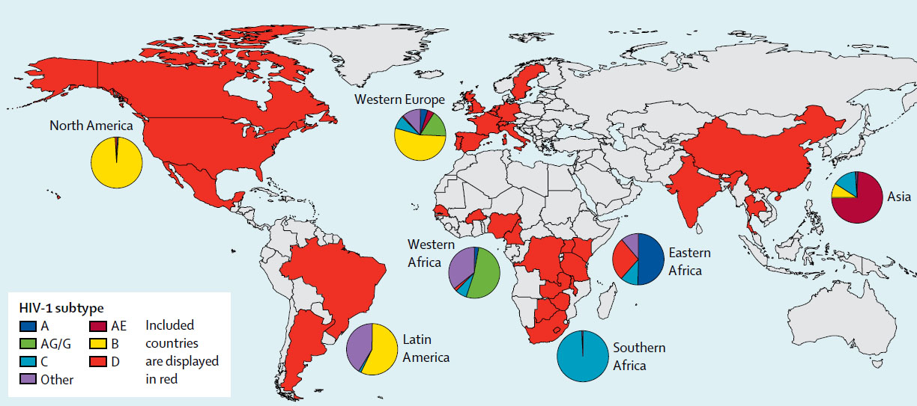

The research, co-authored by researchers at Stanford University and the London School of Hygiene and Tropical Medicine and published in the Lancet Infectious Diseases journal, studied 1,926 HIV patients across the world with uncontrolled HIV despite being prescribed antiretrovirals. They found tenofovir-resistant strains in 60% of patients in sub-Saharan Africa in contrast to 20% amongst patients treated in Europe. Around two-thirds of patients with tenofovir-resistant strains had also become resistant to both other drugs in their regimen, indicating that their treatment had been completely compromised.

The study suggests that in Sub-Saharan Africa, up to 15%* of HIV patients treated with tenofovir-based drug combinations will develop tenofovir resistance in the first year of treatment alone, with this figure rising over time. Resistant strains could be passed on to other individuals, becoming more widespread and potentially compromising global HIV control strategies.

“Tenofovir is a critical part of our armamentarium against HIV, so it is extremely concerning to see such a high level of resistance to this drug,” explains lead author Dr Ravi Gupta (UCL Infection & Immunity), who is also an Honorary Consultant in Infectious Diseases at University College London NHS Foundation Trust. “It is very potent drug with few side-effects, and there aren’t any good alternatives that can be deployed using a public health approach. Tenofovir is used not only to treat HIV but also to prevent it in high-risk groups, so we urgently need to do more to combat the problem of emerging resistance.”

Resistance to a drug usually occurs when a patient doesn’t take their medication regularly enough, and for first-line treatments to work patients generally need to take their medication at least 85-90% of the time. When treatment is interrupted, the virus can develop a resistance to the drugs. Previous research has shown that tenofovir resistant strains are less able to multiply and spread in laboratory experiments. However it has not been clear whether the virus is less likely to spread in real-world conditions.

“If resistant strains of HIV were significantly less effective at spreading in people, we would expect to see lower levels of the virus in patients with the resistant strain,” explains Dr Gupta. “However, we found that virus levels were no lower in individuals with the resistant strain and were high enough to be fully infectious. We certainly cannot dismiss the possibility that resistant strains can spread between people and should not be complacent. We are now conducting further studies to get a more detailed picture of how tenofovir resistant viruses develop and spread.”

Patients in the study whose immune systems were already compromised when they started treatment were 50% more likely to develop tenofovir resistance, as were patients on certain other antiretroviral drugs combined with tenofovir. In many parts of Sub-Saharan Africa, particularly rural locations, supplies are limited so patients often can’t receive treatment until they have advanced HIV disease. The problem with this approach is that by this stage the immune system is weaker so the drugs are acting alone against the virus, increasing the likelihood for failure of the drugs and also development of resistance.

Once a patient’s virus becomes resistant to first-line drugs, the next stage is expensive second-line treatment with greater side effects. Many rural patients do not have access to such drugs, so it is important to try to preserve the effectiveness of first-line treatments.

Co-author Professor Robert Shafer of the Stanford University School of Medicine says: "Public health organizations and global funders have been very effective at expanding antiretroviral drug therapy to increasing proportions of patients in need. This study highlights the need for efforts to ensure that the regimens used to treat HIV retain their effectiveness as long as possible."

**Links**

* [Research paper in *Lancet Infectious Diseases*](https://www.ucl.ac.uk/news/news-articles/0116/www.thelancet.com/journals/laninf/article/PIIS1473-3099(15)00536-8/abstract)
* [Dr Ravi Gupta's academic profile](https://iris.ucl.ac.uk/iris/browse/profile?upi=RGUPT39)
* [Wellcome Trust](http://www.wellcome.ac.uk/)
* [UCL Infection & Immunity](http://www.ucl.ac.uk/infection-immunity)
* [UCL Faculty of Medical Sciences](https://www.ucl.ac.uk/medical-sciences)

**Image**

* Map showing the countries included in the study

**Media contact**

**Harry Dayantis**

Tel: +44 (0)20 3108 3844  
Email: h.dayantis[at] ucl.ac.uk

- See more at: https://www.ucl.ac.uk/news/news-articles/0116/290116-resistance-hiv-drug-common#sthash.YJ6yacAd.dpuf